Downloading Kivy onto the Pi:

In the terminal run:
sudo apt-get update

Then run:
sudo apt-get upgrade

Then run:
pip3
- To check that you have the python3 version

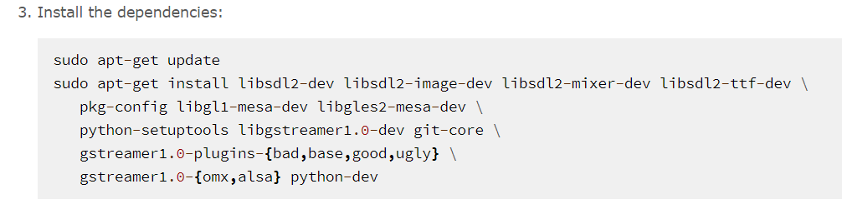

Copy and paste these sections, separately, into the cmd and run:
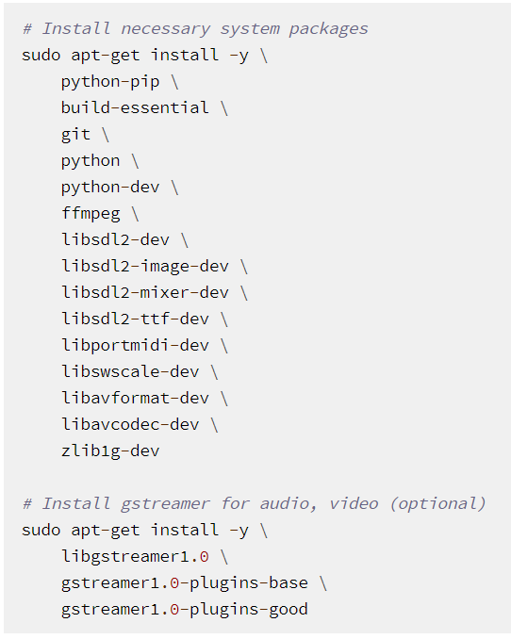
Making sure to change python to python3 and python-dev to python3-dev. Also add python-dev onto the end – doesn’t hurt to have both downloaded.
Then run:
pip3 install cython

Then run:
pip3 install kivy

Then run:
python3

Then type:
import kivy

check in INFO for KIVY is has latest version: e.g. v1.10.1

Then type:
quit()

AND YOU’RE DONE!

